In Memoriam: E.P. “Perk” Floyd, 1918 – 2011

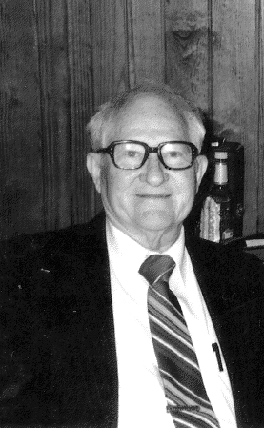

E.P “Perk” Floyd, age 92, of Little Rock, died January 1, 2011. He was born July 18, 1918 in Nathan, Arkansas. A graduate of the University of Arkansas with degrees in both chemistry and zoology, Perk taught high school and college as a professor of sciences at Northeastern University in Tahlequah, Oklahoma. He retired in 1971 as a Commander in the United States Public Health Service Commissioned Corps after 25 years of service in both lab and field endeavors and went on to work as an administrator in the Office of Research and Monitoring at the Environmental Protection Agency.
Perk became interested in birds at age 10 and was an active member in the Audubon Society since 1940. Throughout his life Perk enjoyed teaching others about birds and authored the booklets “All about Bluebirds” in 1987 followed in 1988 by “All about Cardinals.” He especially enjoyed hosting birding groups at his lakeside home in Hensley, Arkansas where they could assist in the intricate process of banding hummingbirds. In a 2005 newspaper article Perk estimated he and wife Leannah had banded 6,000 birds of various species.

As a research scientist, Perk had a keen intellect, but he will also be remembered for his cheerful spirit and his lively sense of humor. He was as comfortable teaching eager first-graders the joy of bird watching as he was presenting a scientific paper at National Audubon Society meetings. Perk was a long time member of the Academy and co-authored 2 papers in the Journal of the Arkansas Academy of Science with the late Dr. John Ricketts.

Always an avid outdoorsman and an early environmentalist, Perk received both state and national recognition for his work and was most recently recognized as the Arkansas Wildlife Federation’s 2009 Conservationist of the Year. Some of his happiest times were spent on the trail, backpacking much of the Appalachian and Ozark Highlands trails. He also enjoyed fly-fishing and photography and was a formidable tennis and chess player well into his 80’s.

Reflecting on his life this past year, Perk said “it has been a barrel of fun.” Perk is survived by two sons; Martin and wife Margaret of Cheneyville, Louisiana, and Larkin and his wife Pam of Berryville, Arkansas.

David A. Saugey, 1173 Hwy 298, Jessieville, AR 71949.

